**Towards Cloud Computing and Blockchain Integrated Applications**

Cloud Computing is a technology widely used in academia and industry, providing varied services on demand. Blockchain technology was developed initially for the creation of a crypto-currency and nowadays is being exploited for several other applications, such as health, agriculture, IoT and education. Some work initiatives are already taking place with the integration of these two technologies, either for research or for cloud service provision. This article aims to present a preliminary discussion on some aspects of integration between blockchain and cloud computing. Contributions of this paper include: (i) presentation of two integrated commercial cloud computing and blockchain environments; and (ii) some research opportunities on the use of both environments.

**EXISTING SYSTEM:**

According to the National Institute of Standards and Technology (NIST), cloud computing is defined as an evolving paradigm. Their definitions, use cases, technologies, problems, risks and benefits will be redefined in discussions between the public and private sectors, and these definitions, attributes, and characteristics will evolve over time. In dealing specifically with the definition, a broadly accepted definition is not yet available.

**DISADVANTAGES OF EXISTING SYSTEM:**

* Any changes in the distributed ledger are executed by transactions are not controlled by the servers.
* Data and transactions are under the control of a third party.
* Transaction history is available for individual servers.

**PROPOSED SYSTEM:**

NIST presents the following definition for cloud computing: “cloud computing is a model that enables convenient and on-demand access to a set of configurable computing resources (for example, networks, servers, storage, applications, and services) which can be quickly acquired and released with minimal managerial effort or interaction with the service provider. These features are: self-service on demand, wide access, resource pooling, fast elasticity, and measured service. The cloud computing environment is composed of three service models. These models are important because they define an architectural standard for cloud computing applications. These models are: Software-as-a-Service (SaaS), Platform as a Service (PaaS) and Infrastructure as a Service (IaaS). Finally, cloud computing deployment models can be divided into public, private, community, and hybrid cloud.

**ADVANTAGES OF PROPOSED SYSTEM:**

* Data and transactions are not under the control of a third party.
* Any transactions in a blockchain are completely recorded in the public ledger in a permanent and verifiable manner.
* Blockchain is a block sequence containing the complete transaction log, acting as a public book, maintained by multiple nodes in a network.

**SYSTEM ARCHITECTURE:**

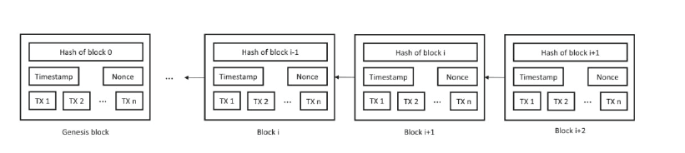

**SYSTEM REQUIREMENTS:**

**HARDWARE REQUIREMENTS:**

* System : Pentium i5 Core.
* Hard Disk : 500 GB.
* Monitor : 15’’ LED
* Input Devices : Keyboard, Mouse
* Ram : 1GB.

**SOFTWARE REQUIREMENTS:**

* Operating system : Windows 10.
* Coding Language : JAVA/J2EE
* Tool : Netbeans 8.2
* Database : MYSQL 5.0

**REFERENCE:**

Emanuel F. Coutinho, Diogo Eliseu Paulo, Antonio Welligton Abreu and Carla I. M. Bezerra Graduate Program in Computer Science (PCOMP) Undergraduate Course in Computer Science Federal University of Ceara (UFC) - Quixada, Ceara, Brazil. **“Towards Cloud Computing and Blockchain Integrated Applications”** IEEE International Conference on Software Architecture Companion**. Date Added to IEEE Xplore: 19 May 2020, INSPEC Accession Number: 19632112, DOI: 10.1109/ICSA-C50368.2020.00033**